Batch: B2 Roll No.: 16010121200

Experiment No. 8

Grade: AA / AB / BB / BC / CC / CD /DD

Signature of the Staff In-charge with date

TITLE: Disk Scheduling Algorithms
_____________________________________________________________________

AIM: Implementation of Disk Scheduling Algorithm like FCFS, SSTF, SCAN, CSCAN, LOOK.
_____________________________________________________________________
Expected Outcome of Experiment:
CO 4. To understand various Memory, I/O and File management techniques.
_____________________________________________________________
Books/ Journals/ Websites referred:

- Silberschatz A., Galvin P., Gagne G. “Operating Systems Principles”, Willey Eight edition.
- Achyut S. Godbole , Atul Kahate “Operating Systems” McGraw Hill Third
Edition.
- William Stallings, “Operating System Internal & Design Principles”, Pearson.
- Andrew S. Tanenbaum, “Modern Operating System”, Prentice Hall.
_____________________________________________________________________
Pre Lab/ Prior Concepts:
- Knowledge of disk scheduling algorithm.
- Calculation of seek time and transfer time etc.

Description of the application to be implemented:
- First Come-First Serve (FCFS):
FCFS is a simple disk scheduling algorithm that serves I/O requests in the order they arrive, without considering the location of the requests on the disk. It can lead to inefficient disk access times, especially when there is a mix of near and far tracks being accessed.

- Shortest Seek Time First (SSTF):
SSTF (Shortest Seek Time First) selects the request that is closest to the current head position, minimizing seek time. This can improve disk efficiency but may lead to starvation of requests located farther away from the current head position.

- Elevator (SCAN):
The disk arm moves in a particular direction and services the requests coming in its path and after reaching the end of the disk, reverses its direction. This algorithm works as an elevator and is hence also known as an elevator algorithm. As a result, the requests at the midrange are serviced more and those arriving behind the disk arm will have to wait.

- CSCAN (Circular SCAN):
CSCAN is similar to SCAN, but it first moves to the end of the disk in the current direction and then scans back. These algorithms reduce seek time by focusing on a specific direction, but requests at the opposite end may face longer wait times.

- LOOK:
LOOK is another variant of SCAN that only scans to the last request in the current direction, avoiding servicing requests at the end of the disk without turning back, which reduces the possibility of long waiting times for certain requests. It strikes a balance between SSTF and SCAN algorithms.

Implementation details: (printout of code)
Requests to be serviced (in FIFO order) – 98, 183, 37, 122, 14, 127, 65, 70
FCFS:
def fcfs(requests, start):
algo_name = "FCFS"
head = start
serviceOrder = []
for req in requests:
reqPos = req
tracks = abs(reqPos - head)
service = (head, reqPos, tracks)
serviceOrder.append(service)
head = reqPos
printTable(serviceOrder, algo_name)
plotGraph(serviceOrder, algo_name)
return
Output:
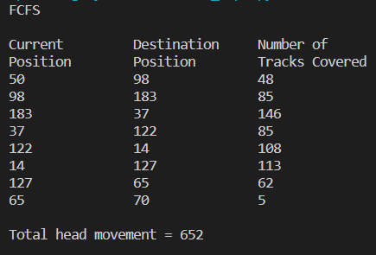
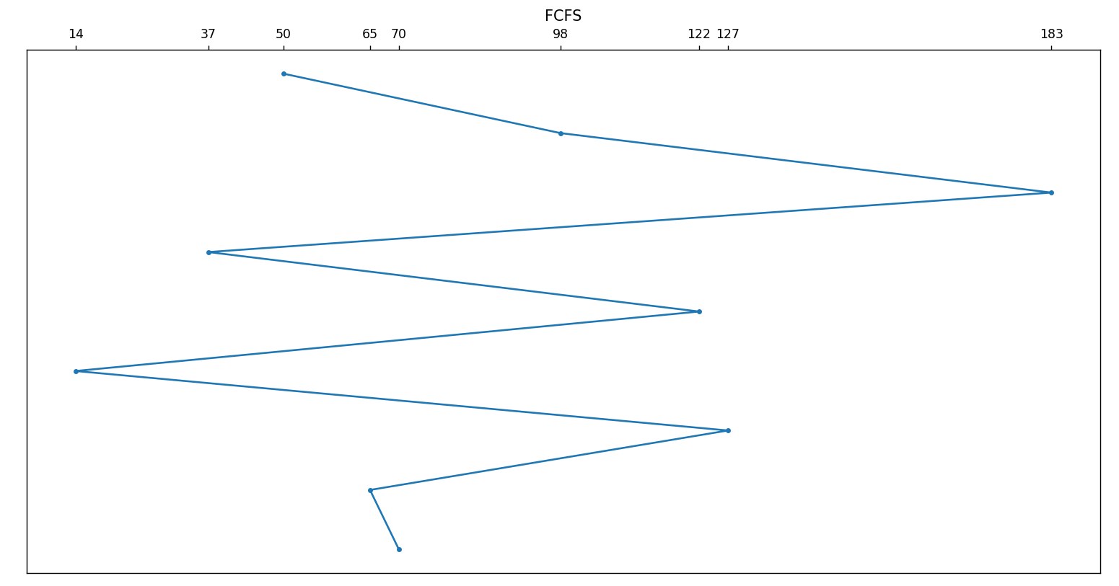
SSTF:
def sstf(requests, start):
algo_name = "SSTF"
requests = requests[:]
head = start
serviceOrder = []
while requests:
seektime = [abs(req - head) for req in requests]
min_seektime = min(seektime)
index = seektime.index(min_seektime)
reqPos = requests[index]
tracks = abs(reqPos - head)
service = (head, reqPos, tracks)
serviceOrder.append(service)
requests.remove(reqPos)
head = reqPos
printTable(serviceOrder, algo_name)
plotGraph(serviceOrder, algo_name)
returnOutput:
Output:
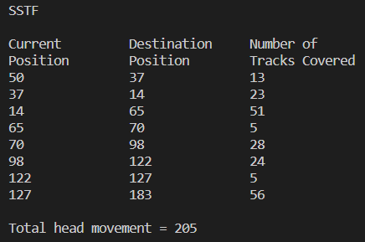
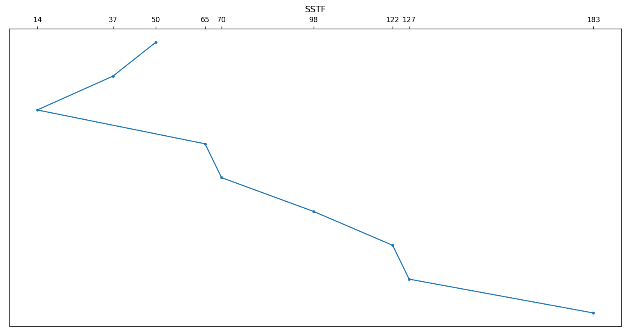
SCAN:
def scan(requests, start):
algo_name = "SCAN"
head = start
reqPos = 0
serviceOrder = []; serviceOrderL = []; serviceOrderR = []
L = [x for x in requests if x < start]
L.sort(reverse = True)
R = [x for x in requests if x >= start]
R.sort()
for reqPos in R:
tracks = abs(reqPos - head)
service = (head, reqPos, tracks)
serviceOrderR.append(service)
head = reqPos
# Go to end of right direction
reqPos = cylinders - 1
tracks = abs(reqPos - head)
service = (head, reqPos, tracks)
serviceOrderL.append(service)
head = reqPos
for reqPos in L:
tracks = abs(reqPos - head)
service = (head, reqPos, tracks)
serviceOrderL.append(service)
head = reqPos
serviceOrder = serviceOrderR + serviceOrderL
printTable(serviceOrder, algo_name)
plotGraph(serviceOrder, algo_name)
return
Output:
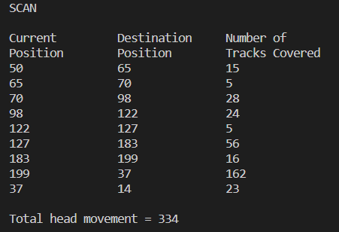
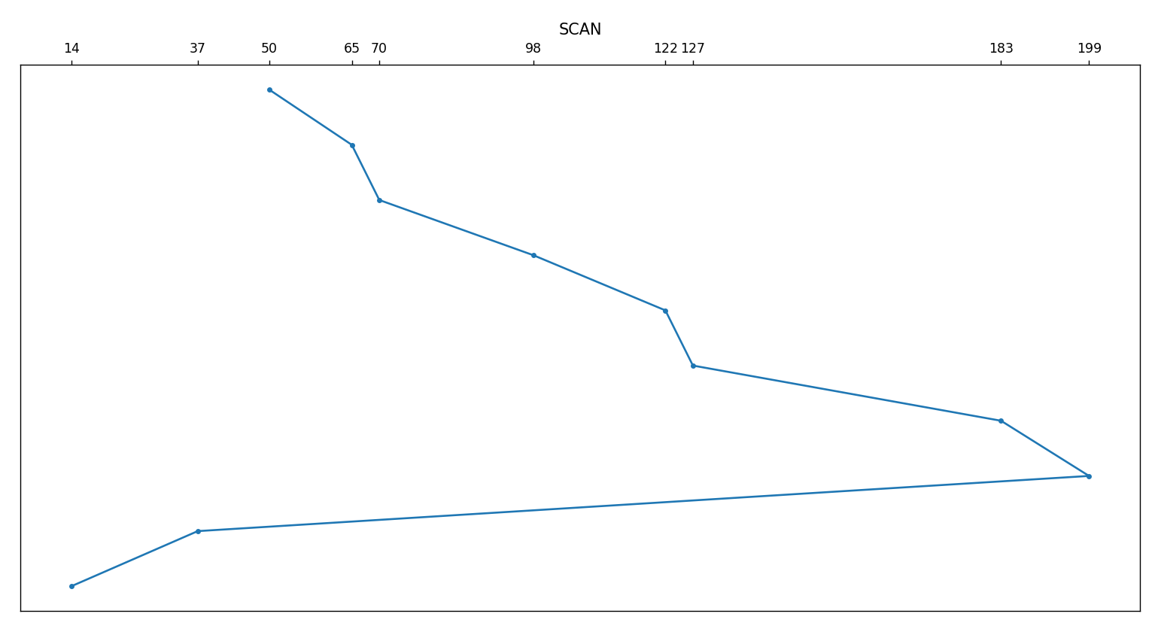
C-SCAN:
def cscan(requests, start):
algo_name = "Circular SCAN"
head = start
reqPos = 0
serviceOrder = []; serviceOrderL = []; serviceOrderR = []
L = [x for x in requests if x < start]
L.sort()
R = [x for x in requests if x >= start]
R.sort()
for reqPos in R:
tracks = abs(reqPos - head)
service = (head, reqPos, tracks)
serviceOrderR.append(service)
head = reqPos
# Go to end of right direction
reqPos = cylinders - 1
tracks = abs(reqPos - head)
service = (head, reqPos, tracks)
serviceOrderL.append(service)
head = reqPos
# Go to extreme left end
reqPos = 0
tracks = abs(reqPos - head)
service = (head, reqPos, tracks)
serviceOrderL.append(service)
head = reqPos
for reqPos in L:
tracks = abs(reqPos - head)
service = (head, reqPos, tracks)
serviceOrderL.append(service)
head = reqPos
serviceOrder = serviceOrderR + serviceOrderL
printTable(serviceOrder, algo_name)
plotGraph(serviceOrder, algo_name)
return
Output:
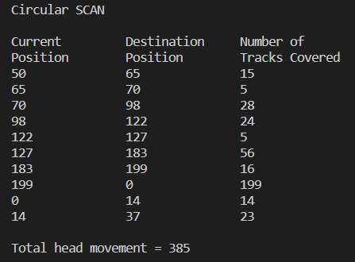
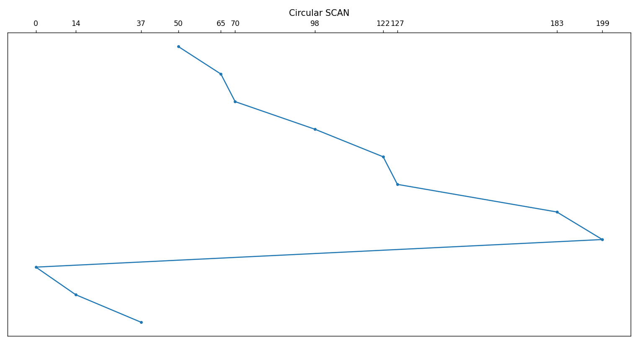
LOOK:
def look(requests, start):
algo_name = "LOOK"
head = start
reqPos = 0
serviceOrder = []; serviceOrderL = []; serviceOrderR = []
L = [x for x in requests if x < start]
L.sort(reverse = True)
R = [x for x in requests if x >= start]
R.sort()
for reqPos in R:
tracks = abs(reqPos - head)
service = (head, reqPos, tracks)
serviceOrderR.append(service)
head = reqPos
for reqPos in L:
tracks = abs(reqPos - head)
service = (head, reqPos, tracks)
serviceOrderL.append(service)
head = reqPos
serviceOrder = serviceOrderR + serviceOrderL
printTable(serviceOrder, algo_name)
plotGraph(serviceOrder, algo_name)
return
Output:
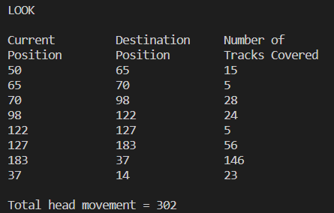
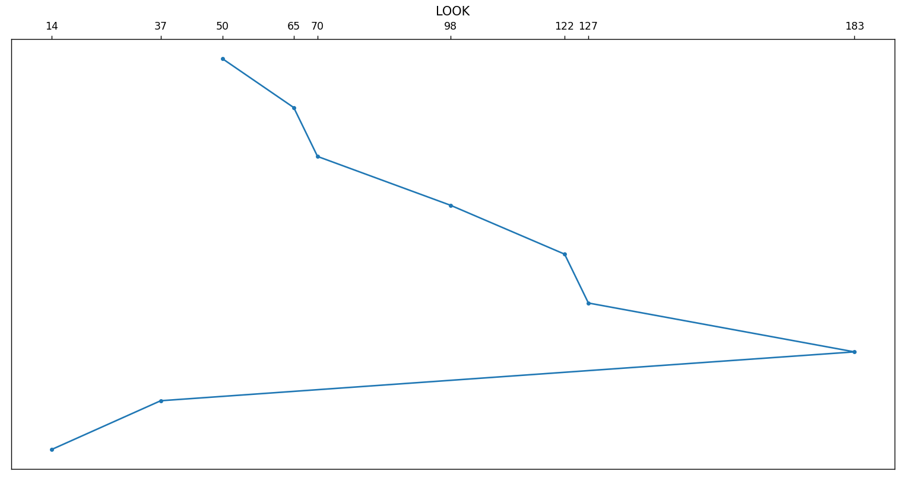
Function to print the table:
def printTable(serviceOrder, name):
print(name, end = "\n\n")
print("Current\t\tDestination\tNumber of")
print("Position\tPosition\tTracks Covered")
for service in serviceOrder:
for value in service:
print(value, end = "\t\t")
print()
print("\nTotal head movement =", sum([x[2] for x in serviceOrder]))
return
Function to plot the graph:
def plotGraph(serviceOrder, name):
x_values = [x[0] for x in serviceOrder]
x_values.append(serviceOrder[-1][1])
y_values = [-x for x in range(len(x_values))]
plt.plot(x_values, y_values, marker = '.')
plt.xticks(x_values)
ax = plt.gca()
ax.xaxis.tick_top()
ax.get_yaxis().set_visible(False)
plt.title(name)
plt.show()

Driver code:
import matplotlib.pyplot as plt
cylinders = 200
requests = [98, 183, 37, 122, 14, 127, 65, 70]
start_head_pointer = 50

# n = int(input("Enter number of requests: "))
# for i in range(n):
# req = int(input(f"Positon {i + 1}: "))
# requests.append(req)

fcfs(requests, start_head_pointer)
sstf(requests, start_head_pointer)
scan(requests, start_head_pointer)
cscan(requests, start_head_pointer)
look(requests, start_head_pointer)

Conclusion:
Successfully implemented Disk scheduling algorithms – FCFS, SSTF, SCAN, CSCAN, LOOK.

Post Lab Descriptive Questions

- A disk drive has 200 cylinders numbered from 0 to 199. The disk head is initially at cylinder 53. The queue of pending requests in FIFO order is:
98, 183, 37, 122, 14, 124, 65, 67.
Starting from the current head position, what is the total distance travelled (in cylinders) by disk arm to satisfy the requests using CSCAN and Look.
Illustrate with figures in each case.
C-SCAN:
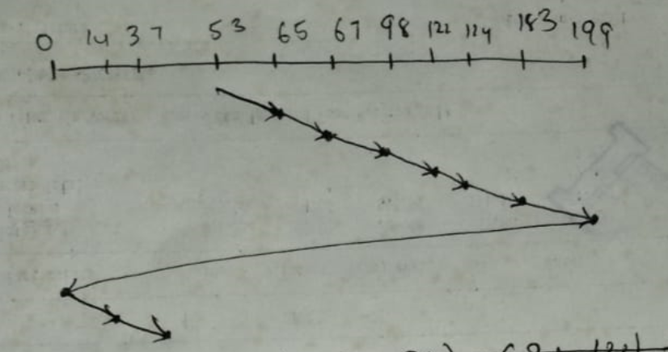
Total distance travelled
= (65-53) + (67-65) + (98-67) + (122-98) + (124-122) + (183-124) + (199-183) + (199-0) + (14-0) + (37-14)
= 382
LOOK:
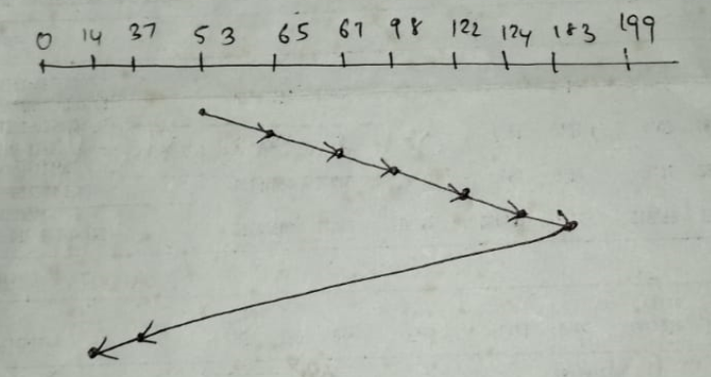
Total distance travelled
= (65 - 53) + (67 - 65) + (98 - 67) + (122 - 98) + (124 - 122) + (183 - 124) + (183 - 37) + (37 - 14)
= 315
Post Lab Objective Questions

- In a hard disk, what rotates about a central spindle
  - Disk
  - Platter
  - Sector
  - None of the above

- The time required to move the disk arm to the required track is known as
  - Latency time
  - Access time
  - Seek time
  - None of the above

Date: 1/11/2023 Signature of faculty in-charge

